WHAT DO YOU REMEMBER?

1. Complete the following table to summarise the properties of the three fundamental particles found in an atom.

Table 1
Fundamental particle Relative mass Relative charge

proton

neutron

electron
(6)
2. Identify the numbered elements in the following extract of the Periodic Table
Li Be B (1) N O F (2)
(3) Mg Al Si P (4) Cl Ar
K (5)
(3)
3. The electron configuration of magnesium is represented by 2,8,2. Write the corresponding configurations for:

(a) lithium, (b) nitrogen, (c) silicon,
(3)
4. The way in which potassium normally ionizes is represented by:

K → K⁺ + e⁻

Write similar equations for the normal ionization of;

(a) magnesium, (b) chlorine, (c) oxygen.
(6)
5. Explain why neon does not ionize in normal chemical reactions.
(1)
6. Which of the following statements about an atom is not true?
The atomic number Z represents:

A the number of electrons going round the nucleus,

B the positive charge on the nucleus,

C the number of neutrons in the nucleus,

D the element’s position in the Periodic Table.
(1)
TOTAL 20 marks

Exercise 1 Define the terms atomic number and mass number.

Exercise 2 Explain what isotopes are, using Nitrogen as an example.

Exercise 3 The table shows the mass number and number of neutrons in the nucleus, for 4 atoms; W, X, Y and Z.

 | W | X | Y | Z
Mass number | 36 | 39 | 40 | 40
Neutrons in nucleus | 18 | 20 | 21 | 22

(a) Write down the atomic numbers of the four atoms

(b) Which of the four atoms are isotopes of the same element?

Exercise 4 (a) Use Table 2 to identify the stable isotopes of the following elements:

(i) Ar (ii) Cu (iii) Si

Describe each one, using isotopic symbols.

(b) Write down the number of neutrons in the nucleus of each isotope.

CALCULATING THE RELATIVE ATOMIC MASS OF AN ELEMENT

Exercise 7 Chlorine consists of isotopes of relative masses 34.97 and 36.96 with natural abundances of 75.77% and 24.23% respectively.
Calculate the mean relative atomic mass of naturally occurring chlorine.

Exercise 8 Copper (atomic number 29) has two isotopes, the first of relative atomic mass 62.9 and abundance 65%, the second of relative atomic mass 64.9 and abundance 35%.
Calculate the mean relative atomic mass of naturally occurring copper.
Exercise 9 Using mass spectrometry, the element gallium has been found to consist of 60.4 per cent of an isotope of atomic mass 68.93 and 39.6 per cent of an isotope of atomic mass 70.92.
Calculate, to three significant figures, the relative atomic mass of gallium.

Exercise 10 (a) Define first ionisation energy.

(b) Write an equation to show the first ionisation energy of sodium.

(d) What are the general trends in first ionisation energy
(i) across each period;

(ii) down each group.

Exercise 11(a) Write equations to show the first, second and third ionisation energies
of aluminium.

(b) Would you expect the values of these ionisation energies to increase or decrease, in the order: 1st, 2nd, 3rd?

(c) Explain your answer to (b).

Exercise 14 Here are the logarithms of all the successive ionisation energies for a given element, X.

Electron number | 1 | 2 | 3 | 4 | 5 | 6 | 7 | 8
log₁₀ I.E. | 3.12 | 3.53 | 3.72 | 3.88 | 4.04 | 4.12 | 4.85 | 4.92

(a) Plot log₁₀ I.E. against the number (first, second, third etc.) of the electron removed.
(b) Write down the electron configuration of this element.
(c) To which group of the Periodic Table does the element belong?
(d) What is the formula of the ion that this element would normally form in a chemical reaction?

Exercise 15 The following table shows the first six ionisation energy values for each of four consecutive elements in the Periodic Table.

 | Ionisation energy in kJ mol⁻¹
Element | First | Second | Third | Fourth | Fifth | Sixth
W | 1260 | 2300 | 3800 | 5200 | 6500 | 9300
X | 1520 | 2700 | 3900 | 5800 | 7200 | 8800
Y | 420 | 3100 | 4400 | 5900 | 8000 | 9600
Z | 590 | 1100 | 4900 | 6500 | 8100 | 10500

Which of the elements do you think
(a) is a noble gas,
(b) will form an ion with a single positive charge,
(c) will form an ion with a double positive charge?

Exercise 16 Plot a graph of first ionisation energy against atomic number for the first twenty elements (i.e. from H to Ca).
Label the vertical axis: ‘1st ionisation energy/kJ mol⁻¹ ’, and extend the scale from zero to 2500 (in intervals, say, of 500).
Label the horizontal axis: ‘Atomic number’ and extend the scale from zero to 20.
Label each point with the symbol for the element and join each point to the next by a straight line.

Exercise 17 Explain the changes in first ionisation energy
(a) between hydrogen and helium,
(b) between helium and lithium,
(c) between beryllium and boron,
(d) between nitrogen and oxygen,
(e) along the peaks (noble gases) or alternatively along the troughs (alkali metals).

PAST EXAM QUESTIONS

1. The diagram below represents the series of lines which make up the emission spectrum of atomic hydrogen in the u.v. region (not all lines are shown).
X

Frequency(Hz) A B C D
2.47 2.93 3.09 3.16
x 10¹⁵ x 10¹⁵ x 10¹⁵ x 10¹⁵

(i) What can be deduced from the fact that the spectrum consists of lines?

(ii) What do you observe about the spacing of the lines and what can you deduce from this?
(iii) What is the significance of the convergence limit, X, of the series?
(6 marks)

2. (a)(i) What happens to the electron in the production of a single line in the atomic emission spectrum of hydrogen?

(ii) Why does this process result in a single line?

(iii) For a particular series of lines in the hydrogen spectrum, the lines get closer together towards one end. State at which end they are closer and explain why this is so.
End at which the lines are closer
Explanation
(5 marks)

3. (a)(i) In discussing the atomic emission spectrum of hydrogen, what is meant by a series and what does each specified series in the emission spectrum have in common?
(2 marks)

(b) The diagram below (not to scale) represents some of the electronic energy levels in the hydrogen atom.

n = ∞
n = 6
n = 5
n = 4
n = 3
n = 2
n = 1

(i) What is the significance of an electron in the level marked n = ∞ ?

(ii) Mark on the energy level diagram an arrow to represent the ionisation energy of hydrogen. Label this arrow ‘A’.

(iii) Mark on the energy level diagram an arrow to represent the lowest energy transition in the Balmer emission spectrum (the series found in the visible region). Label this arrow ‘B’.
(3 marks)
(c) Of the elements in the Periodic Table from hydrogen to neon, state which has the highest first ionisation energy and which has the lowest. Give reasons for your answers.
Highest first ionisation energy
Reasons
Lowest first ionisation energy
Reasons
(6 marks)

4. This question is about ionisation energies and the electron structure of atoms. The diagram below shows a plot of first ionisation energies against atomic number.

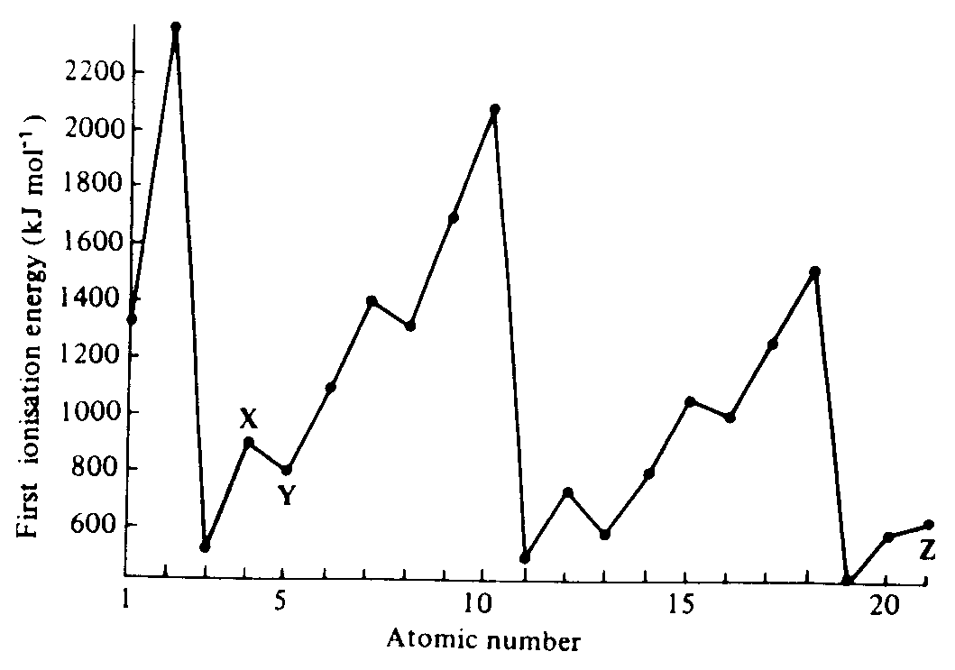

(a) Mark on the diagram with letter A the two points corresponding to the elements which has one electron in its outer shell.
(2)
(b) Mark on the diagram with the letter B two points corresponding to any two of the noble gases.
(2)
(c) Mark on the diagram with letter C the two points corresponding to the halogen elements.
(2)
(d) Explain why the ionisation energy of the element marked Y on the diagram is lower than that of element X.
(3)
(e) The series of ten elements starting at the element marked Z in the diagram have first ionisation energies that increase only gradually with atomic number.
(i) these elements are known as
(ii) the electron shell that is filling in these elements is
(2)
Question 4 continued

(iii) The successive ionisation energies of each of two elements E₁ and E₂ in the fourth period have the following values (kJ mol⁻¹ )
 | I₁ | I₂ | I₃
E₁ | 402 | 2650 | 3850
E₂ | 699 | 1470 | 2800

Which one of these elements is a transition element?
(1)
State briefly your reasoning
(1)
TOTAL 13 marks

5. The following graph shows the first ionisation energies of twelve consecutive elements in the Periodic Table. Some of the elements are marked by arbitrary letters.

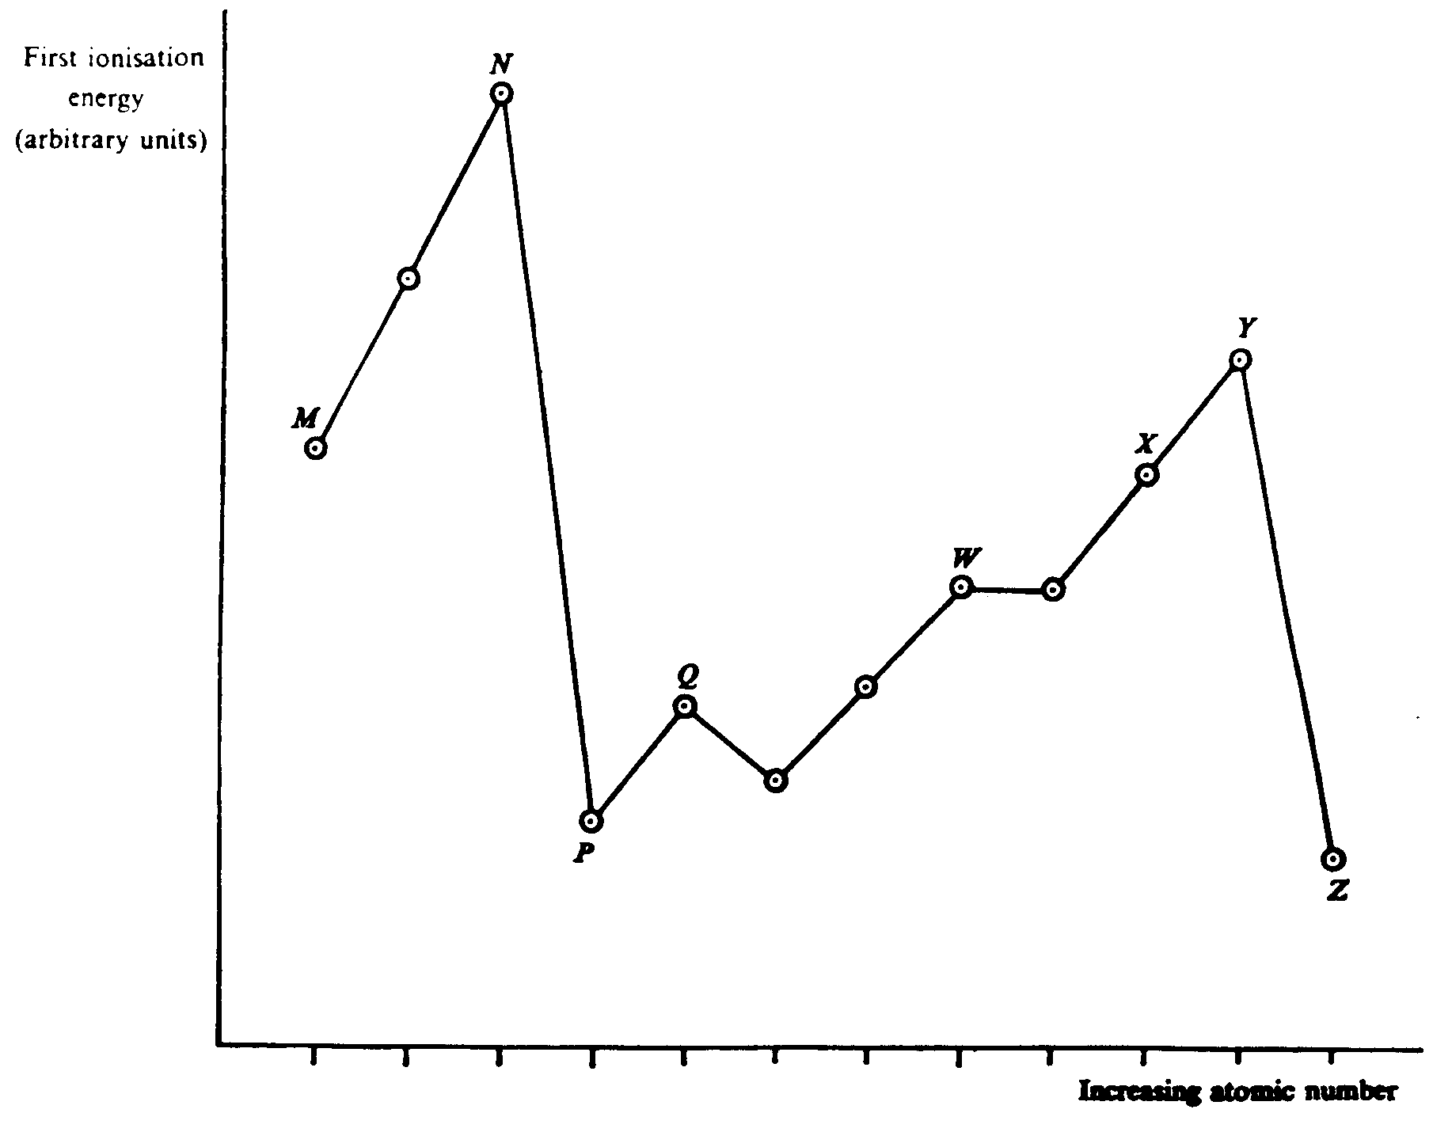

Question 5 continued

(a) Name four consecutive elements for which the first ionisation energy would vary according to the pattern W and Y in the graph.
(2)
(b) Which one of the elements marked on the graph by letters would have the highest second ionisation energy?
(2)

TOTAL 4 marks

